Film Log For Hercules – Brennan Giles

1. Hercules is a nostalgic gem for many Americans that grew up watching it, and for that reason it has had a tremendous effect on young mind’s views towards male and female roles. Predominately, the message is that Men are the only people capable of being strong enough to be heroes and it is their duty to protect defenseless, hopeless women. This is depicted through the character arcs of Hercules vs. Meg, both physically and mentally. When such disparities exist it creates problems, and according to Time “When the beautiful and romantic stories we grow to love in childhood set a standard that exaggerates gender differences and makes them seem natural — built into our very bone structures — it gives us a more limited, and less complex, vision of our human potential” (Time 1). It is thus important that we investigate how this exaggerated difference exists in popular films such as Hercules.
2. Meg is first introduced struggling against Hade’s henchmen. Sensing her distress Hercules assumes that as a woman she cannot handle herself and decides to step in, despite her insisting she has it under control. From the moment Hercules meets her until the end of the movie, he assumes that Meg needs his help and forces himself into her business because he fancies himself a hero. Hades understands Hercules’ obsession with proving himself and takes advantage of this by using Meg to manipulate him. By now you can guess what trope will take over next: Meg will use her beauty to manipulate Hercules but in the end will fall for him and switch sides. As the only lead female in the entire movie it is disappointing that the writers portrayed her as a traitor, manipulator, and damsel in distress needing to be saved by the male protagonist all within the span of an hour. As a side note, the physical representation of the characters is extreme; “**they all are incredibly thin with tiny, tucked in waists” (femdisney 1).**

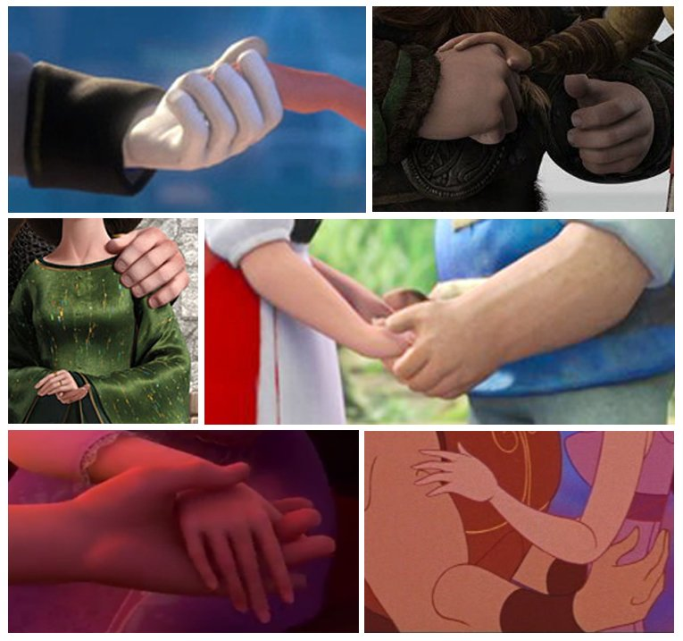

Hercules is so comically larger than Meg it is distracting once the viewer takes note. Through both their attitudes and physical representations, Disney takes a firm stance on which gender gets the role of hero.

1. I thoroughly enjoyed the film watching it again. The music is fantastic and the animation is great. I never felt everything I discussed above actually detracted from the movie because it is based on previously established tales with fantasy monsters and it never really felt like there were political undertones or messages. Hercules is so much bigger than Meg because he literally has the strength of Zeus, and he wants to save people like Meg because he is just a loving guy. Meg starts misguided as many people do but she redeems herself in a satisfying way and helps Hercules to defeat Hades in the end. I think giving Hercules a character flaw beyond “not strong enough” or “naïve” would have made his story more effective however.
2. The animation and music were the most striking in the film. My favorite songs all had the gospel girls singing and it really contributed to the “flavor” of the movie. I think more mainstream movies integrating that kind of music would be fantastic and that is what I would do in my film.

Citations Used:

Cohen, Philip. “The Trouble With Disney's Supertiny Princesses and Hulking Heroes.” *Time*, Living, 28 Jan. 2015, time.com/3667700/frozen-brave-disney-princesses-heroes-and-sexism/.

Feministdisney. “Disney's Hercules: Seeing through It ‘for a Peloponnesian Minute.’” *Feminist Disney*, 31 Dec. 2011, feministdisney.tumblr.com/post/15088512299/disneys-hercules-seeing-through-it-for-a.